**Q6.**

clear all; close all; clc;

load('hw10p6_data.mat')

%% To inspect the scatter plot..

for i = 1:1000

plot(X(1,i),X(2,i),'ko'); hold on;

end

%% Initialization..on observing the scatter plot

k = 1; %number of iterations

ex(k) = 1;

q = [1 2 3 4 5]; %number of gaussian distributions

n = 1; % varies from 1 to 1000

m(:,1,k) = [-0.8; 0.15]; m(:,2,k) = [-0.5; 0.05]; m(:,3,k) = [0.025; 0.04]; m(:,4,k) = [0.6; -0.05]; m(:,5,k) = [0.92; -0.07];

b(q,k) = [0.1 0.2 0.4 0.2 0.1];

cov(:,:,1,k) = 0.026*eye(2); cov(:,:,2,k) = 0.022*eye(2); cov(:,:,3,k) = 0.046*eye(2); cov(:,:,4,k) = 0.013*eye(2); cov(:,:,5,k) = 0.003*eye(2);

%cov(:,:,1,k) = eye(2); cov(:,:,2,k) = eye(2); cov(:,:,3,k) = eye(2); cov(:,:,4,k) = eye(2); cov(:,:,5,k) = eye(2);

al = 0;

%%

while (abs(ex(k) - al) > 0.0001)

for n = 1:1000

for q = 1:5

phi(k,n,q) = (1/((2*pi)*sqrt(det(cov(:,:,q,k))))*(exp(-0.5*((X(:,n) - m(:,q,k))'*(inv((cov(:,:,q,k))))*(X(:,n) - m(:,q,k))))));

end

end

sumo = zeros(1,1000);

for n = 1:1000

for q = 1:5

sumo(n) = sumo(n) + b(q,k)*phi(k,n,q);

end

end

for q = 1:5

for n = 1:1000

g(k,n,q) = (b(q,k)*phi(k,n,q))/sumo(n);

end

end

for q = 1:5

b(q,k+1) = 0;

for n = 1:1000

b(q,k+1) = b(q,k+1) + g(k,n,q);

end

b(q,k+1) = b(q,k+1)/1000;

end

for q = 1:5

m(:,q,k+1) = zeros;

for n = 1:1000

m(:,q,k+1) = m(:,q,k+1) + g(k,n,q)*X(:,n);

end

m(:,q,k+1) = m(:,q,k+1)/(1000*b(q,k+1));

end

for q = 1:5

cov(:,:,q,k+1) = zeros;

for n = 1:1000

cov(:,:,q,k+1) = cov(:,:,q,k+1) + g(k,n,q)*(X(:,n)-(m(:,q,k+1)))*(X(:,n)-(m(:,q,k+1)))';

end

cov(:,:,q,k+1) = cov(:,:,q,k+1)/(1000*b(q,k+1));

end

%% for calculating new E

ex(k+1) = 0;

for n = 1:1000

for q = 1:5

phi(k+1,n,q) = (1/((2*pi)*sqrt(det(cov(:,:,q,k+1))))*(exp(-0.5*((X(:,n) - m(:,q,k+1))'*(inv((cov(:,:,q,k+1))))*(X(:,n) - m(:,q,k+1))))));

end

end

sumon = zeros(1,1000);

for n = 1:1000

for q = 1:5

sumon(n) = sumon(n) + b(q,k+1)*phi(k+1,n,q);

end

end

for q = 1:5

for n = 1:1000

g(k+1,n,q) = (b(q,k+1)*phi(k+1,n,q))/sumon(n);

end

end

for n = 1:1000

for q = 1:5

% ex(k+1) = ex(k+1) + g(k+1,n,q)*(log(abs((b(q,k+1))))+log(abs((phi(k+1,n,q)))));

ex(k+1) = ex(k+1) + g(k+1,n,q)*(log(abs((b(q,k+1)))) *(abs((phi(k+1,n,q)))));

end

end

k = k + 1;

al = ex(k-1);

% abs(ex(k) - al)

end

syms x y

f1(x,y) = (1/((2*pi)*sqrt(det(cov(:,:,1,k))))*(exp(-0.5*([x;y] - m(:,1,k))'*(inv((cov(:,:,1,k))))*([x;y] - m(:,1,k)))));

fcontour(f1,[-1.5 1.5 -0.15 0.25],'MeshDensity',1000); hold on;

f2(x,y) = (1/((2*pi)*sqrt(det(cov(:,:,2,k))))*(exp(-0.5*([x;y] - m(:,2,k))'*(inv((cov(:,:,2,k))))*([x;y] - m(:,2,k)))));

fcontour(f2,[-1.5 1.5 -0.15 0.25],'MeshDensity',1000); hold on;

f3(x,y) = (1/((2*pi)*sqrt(det(cov(:,:,3,k))))*(exp(-0.5*([x;y] - m(:,3,k))'*(inv((cov(:,:,3,k))))*([x;y] - m(:,3,k)))));

fcontour(f3,[-1.5 1.5 -0.15 0.25],'MeshDensity',1000); hold on;

f4(x,y) = (1/((2*pi)*sqrt(det(cov(:,:,4,k))))*(exp(-0.5*([x;y] - m(:,4,k))'*(inv((cov(:,:,4,k))))*([x;y] - m(:,4,k)))));

fcontour(f4,[-1.5 1.5 -0.15 0.25],'MeshDensity',1000); hold on;

f5(x,y) = (1/((2*pi)*sqrt(det(cov(:,:,5,k))))*(exp(-0.5*([x;y] - m(:,5,k))'*(inv((cov(:,:,5,k))))*([x;y] - m(:,5,k)))));

fcontour(f5,[-1.5 1.5 -0.15 0.25],'MeshDensity',1000); hold on;

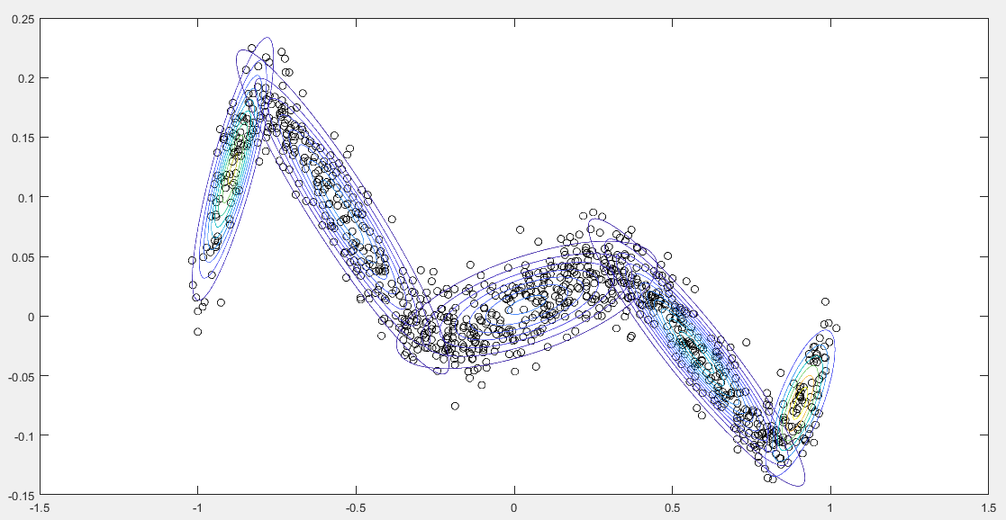

130 iterations.

Final beta values:  
0.0908958216750749

0.237967609683805

0.348975375046794

0.235930943516627

0.0862302500776987

Final means:

-0.8891 -0.5422 0.0394 0.5762 0.9037

0.1233 0.0873 0.0093 -0.0305 -0.0732

Final Covariance matrices:

ans(:,:,1) =

0.0037 0.0027

0.0027 0.0027

ans(:,:,2) =

0.0261 -0.0099

-0.0099 0.0043

ans(:,:,3) =

0.0426 0.0034

0.0034 0.0007

ans(:,:,4) =

0.0238 -0.0073

-0.0073 0.0026

ans(:,:,5) =

0.0032 0.0013

0.0013 0.0010